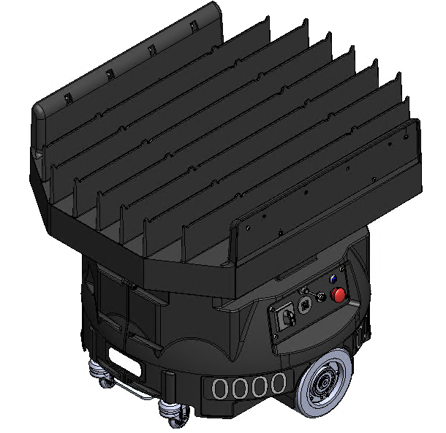
FlexBot Manual
FlexBot Theory of Operation Document Revision History
Revision | Date | Brief description of the Changes | Section(s) affected | Originator of Change
01 | 04/22/2022 | Initial Release |  | Paul Conroy
The information in this document is current as the of the date of publication and is subject to change without notice.

Table of Contents
Table of Figures 5
FlexBot Overview 7
Major Sections of the FlexBot 8
Mobile Base 8
Drive Motors 9
Battery 10
Battery Charging 12
User Interface (UI) 13
Port Side UI 13
Starboard Side UI 14
Casters 15
PGV (Position Guided Vision) 16
PCBAs and cabling 17
Motor Control Board (MCB) 17
Application Processor Board (APB) 17
Power Distribution Board (PDB) 17
Siemens Carrier Board (SCB) 17
Obstacle detection Sensor 18
WIFI Antenna 18
Payload Lift/Lower Assembly 19
Scissor Frame 20
Lift Motor/ Crank Arm/ Reed Switch 21
Motor Control Board (MCB) 22
Wire Routing & Cable Management 23
Energy Chain Entrance Wires and Cables 24
Encoder and Slip Ring Wires and Cables 25
Rotary Stage 26
Deck Rotate Motor 27
Deck Rotate Motor Control Board (MCB) 27
Pulley/Belt/Slew Ring 28
Cover Plate 28
Slip Ring/Absolute Encoder 29
G-Clip 30
Payload Deck and Covers 31
Molded Payload Deck 31
Deck Presence Sensors 31
Payload Deck Wire Guarding 32
Housings and Shield 33
LED Panels 34
FlexBot Safety 35
Safety Features during Operation 35
Safety Controller Communication 36
Safety Controller Verification 36
Direction and distance measurements between fiducials 36
Correlation between distance travelled and new fiducials 36
Maximum velocity verification 37
Siemens Profisafe message validity verification 37
High Level Safety Controller Verification 37
Fixed map of fiducials of the FlexTile field 37
Correlation of reported fiducials and a fixed map of fiducials 37
FlexBot location history 38
Correlation of adjacent reported fiducials 38
Siemens Profisafe message validity verification 38
Safety System User Interface 38
E-Stop Button 39
E-Stop Illumination 39
Maintenance Connector 39
Reset Button 39
Reset Button Illumination 39
Maintenance Safety 39
Safely Moving the FlexBot 40
Safely Performing Maintenance on the FlexBot 44
FlexBot Commissioning 48
Unboxing 48
General Functionality Testing 48
FlexBot Static Function Test 48
FlexBot Drive Test 48
FlexBot Preventive Maintenance 49
150 Mile Inspection 49
FB Maintenance Tool 50
Files Needed on the RT Laptop 50
Comprehensive Tests 51
FlexBot Maintenance Procedures Index 52

Table of Figures
Figure 1 - Port Side of FlexBot 7
Figure 2 - Starboard Side of FlexBot 7
Figure 3 - Mobile Base: PN 8
Figure 4 - Drive Motors 9
Figure 5 - Battery Bay Location 10
Figure 6 - Caster Bracket Location 11
Figure 7 - Battery 11
Figure 8 - Charging and Electronics Bay 12
Figure 9 - Port Side 13
Figure 10 - Starboard Side 14
Figure 11 - Casters 15
Figure 12 – PGV location 16
Figure 13 - Obstacle Detection Sensors 18
Figure 14 - WIFI antenna locations 18
Figure 15 - Payload Lift and Lower Assembly 19
Figure 16 - Welded Scissor frame with rollers and pins 20
Figure 17 - Motor, Crank Arm, and Reed Switch 21
Figure 18 - Motor Control Board (MCB) 22
Figure 19 - MCB Locations on lift lower assembly 22
Figure 20 - Cable management locations - View 1 23
Figure 21 - Cable management locations - View 2 23
Figure 22 - Energy Chain Location Entrance 24
Figure 23 - Encoder and slip ring wires 25
Figure 24 - Deck Rotate Assembly 26
Figure 25 - Deck Rotate Motor 27
Figure 26 - Pulley, Belt, and Slew Ring 28
Figure 27 - Cover Plate, Belt Drive 28
Figure 28 - Slip Ring and Absolute Encoder - View 1 29
Figure 29 - Slip Ring and Absolute Encoder - View 2 29
Figure 30 - G-Clip 30
Figure 31 - Molded Deck with Side Covers 31
Figure 32 -Deck Presence Locations 31
Figure 33 - Molded Deck with wire guards 32
Figure 34 - Housings and Shield 33
Figure 35 - FlexBot 2.0 Safety System Block Diagram 35
Figure 36 - FlexBot Safety System User Interface 38
Figure 37 - FlexBot Removal Tool (FRT) highlighting caster lift points 40
Figure 38 - FlexBot Lift 41
Figure 39 - FlexBot Lift Arms 42
Figure 40 - FlexBot Team Lift 43
Figure 41 - The FlexBot Cradle Orientation 44
Figure 42 - Port Side 45
Figure 43 - Starboard Side 45
Figure 44 - Port Side Panel with Power Switch in Vertical Off Position 46
Figure 45 - Maintenance Dongle Receptable Location 47
Figure 46 - Before and after Maintenance Dongle attachment 47

FlexBot Overview
The FlexBot (PN: 108220) is the mobile robot that is a major component of the FlexTiles system. It is responsible for the movement and physical sortation of containers. It picks up containers from the induct FlexFeed, drives the container to the FlexShelves for temporary storage, and then drives it to the discharge FlexFeed. The FlexBot is capable of forward, limited backward, and rotation motion while the payload deck is capable of lift, lower, and rotation. Additionally, the FlexBot also has additional built in safety features to ensure safe operations.
The FlexBot has a fixed orientation described as port and starboard; standardizing orientation terminology to reduce chances of confusion. The port side of the FlexBot has the power switch while the starboard side of the FlexBot has the LCD. See below for pictures of the port and starboard sides of the FlexBot.
In this chapter, the part number for the illustrated item is displayed within the parentheses as shown in Figure 1.
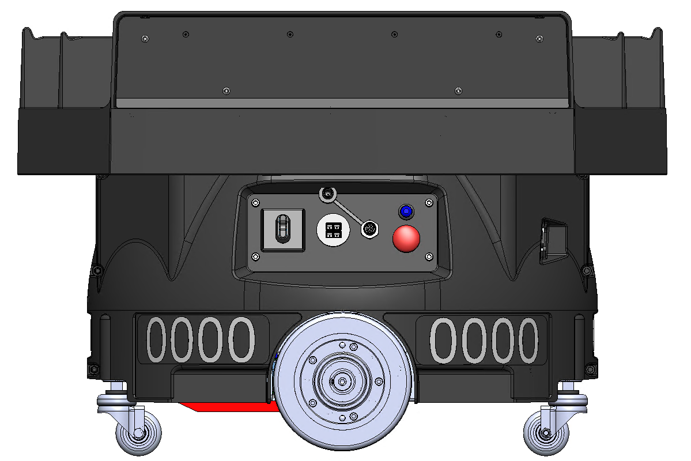
Figure 1 - Port Side of FlexBot
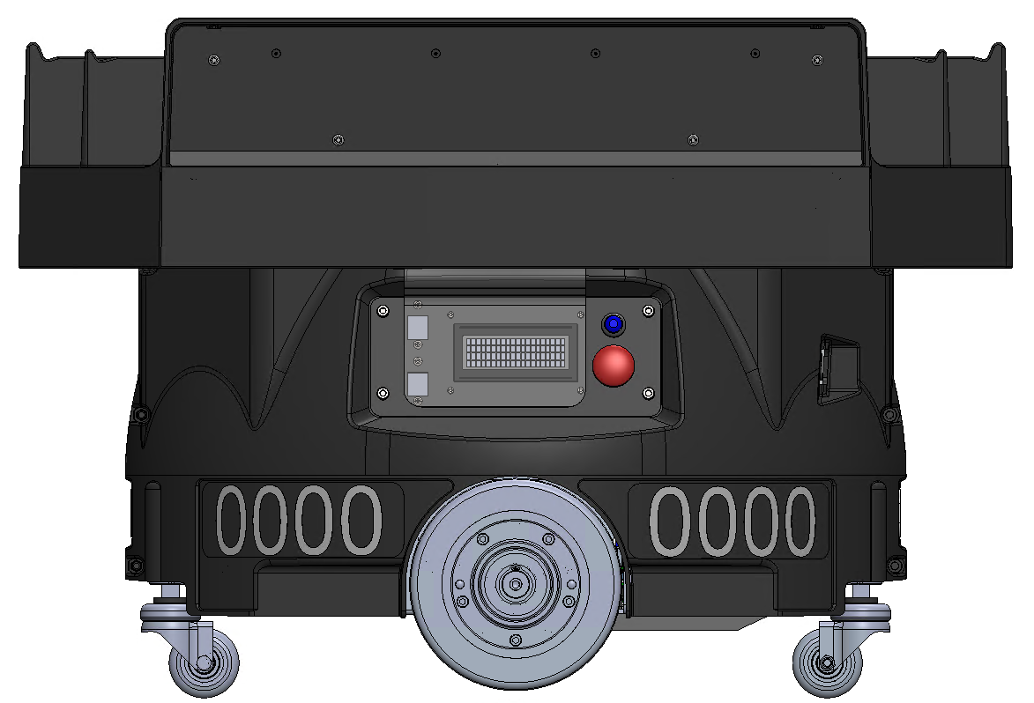
Figure 2 - Starboard Side of FlexBot

Major Sections of the FlexBot
Section | Contains
Mobile Base | Contains the drive wheels and motors, the battery, the majority of the PCBAs
Payload Lift and Lower | Lifts and lowers the payload deck. It connects the drive base to the rotary stage.
Rotary Stage | Rotates the payload deck.
Payload Deck | The large plastic piece on top of the FlexBot that holds the containers as they move. There are four pairs of sensors used to detect whether there is a container on the payload deck.
FlexBot Housings and Covers | The outer pieces of plastic that cover the FlexBot.

Mobile Base
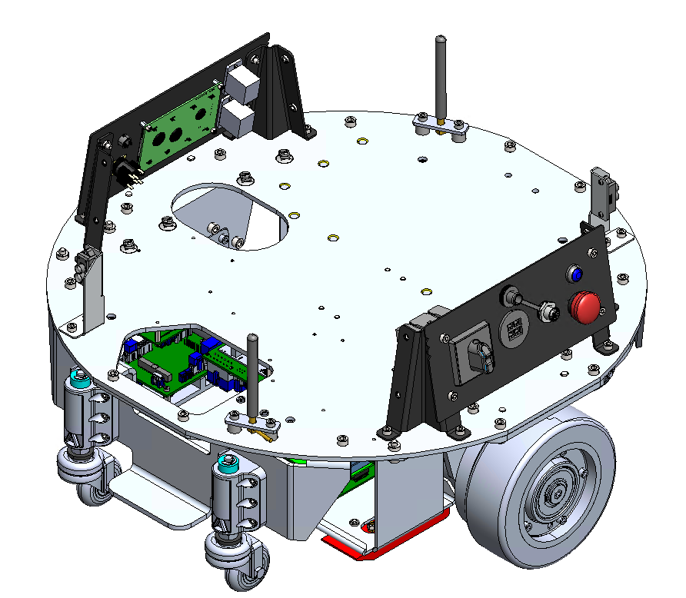
Figure 3 - Mobile Base: PN
The mobile base (PN: 107744) of the FlexBot is the core of the robot. It holds a large majority of components that are critical to the FlexBot’s function. Critical areas of the mobile base are listed below.

Drive Motors
The drive motors (PN: 108471) are what allows the FlexBot to move in any direction. These motors can spin in both directions. FlexBots normal travel motions are forward and rotating either to the port or starboard. The port and starboard drive motors use the same part number.
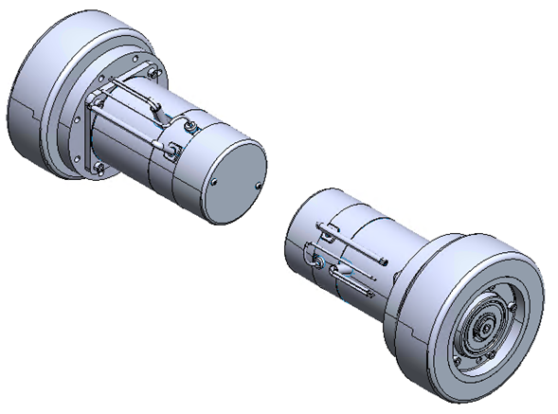
Figure 4 - Drive Motors

Battery
The FlexBot is powered by an onboard battery (PN: 109100). It requires periodic charging done automatically during normal operation and is managed by the FlexBot firmware. During maintenance and debugging the battery may have to be charged manually.
To access the battery you must remove, or swing open the caster bracket (PN: 108078) and then undo a Velcro strap that is holding the battery in place. Once the Velcro straps are undone, the battery can be partially slid out of the battery bay. Two final wired connections must be disconnected to free the battery from the FlexBot.
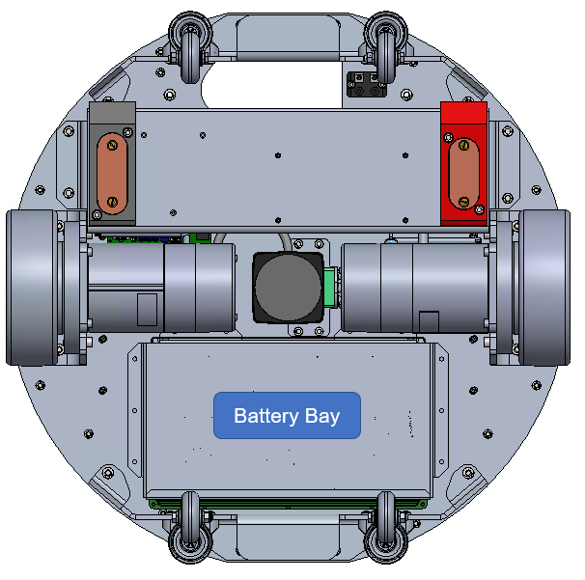
Figure 5 - Battery Bay Location
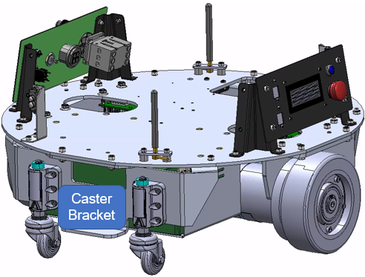
Figure 6 - Caster Bracket Location
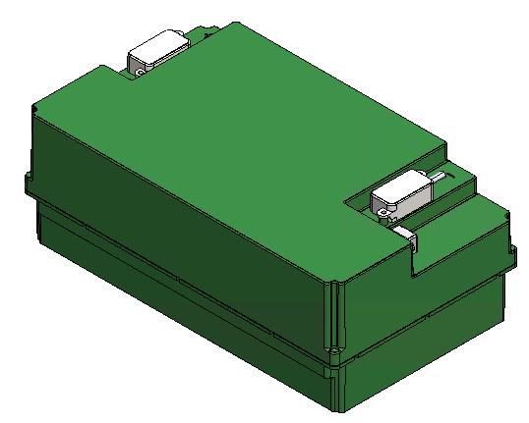
Figure 7 - Battery

Battery Charging
The Charging & Electronics Bay ((PN: 109445) and contacts contain the electronic systems and pads for the FlexBot to charge the onboard battery using the charging points on the FlexTiles floor.
To reduce the risk of the charging system shorting, the negative contact is larger to ensure it connects first.
The positive charging contact block is colored red while the negative charging contact block is colored black.
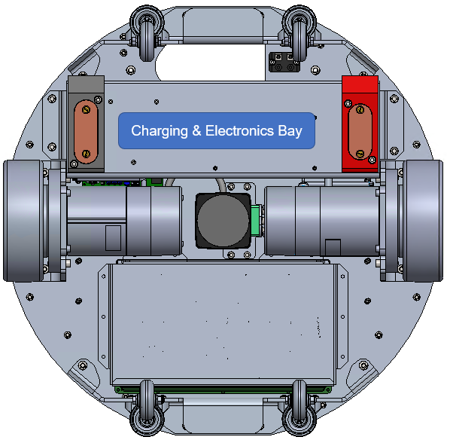
Figure 8 - Charging and Electronics Bay

User Interface (UI)

Port Side UI

Figure 9 - Port Side
Part | Purpose
Power Switch | Physically controls the power state of the FlexBot. The power switch in the vertical position is off and in the horizontal position is on.
Emergency Stop | This red button inhibits any FlexBot motion when pressed. Rotate the button ¼ turn clockwise to release the button. There is an E-Stop button on both sides of the FlexBot. Both operate in the same manner. Only one needs to be engaged to stop motion. This button will blink twice per second when engaged and no light will be on in normal operation.
Dongle Port | The maintenance dongle plugs in this port when performing maintenance and debugging on the FlexBot
Shore power Port | Used to charge the battery manually when the FlexBot is off the field during maintenance.
Safety Reset Button | This blue button is used to reset the safety system in the FlexBot. There is one on both sides of the FlexBot. The small LED in the center of this button will signify one of the three different states:  - Off- Normal Operation  - Blinking twice per second - The button needs to be pressed to enter a normal operating state  - Blinking once every three seconds - The FlexBot is located outside of the normal operating zone.

Starboard Side UI
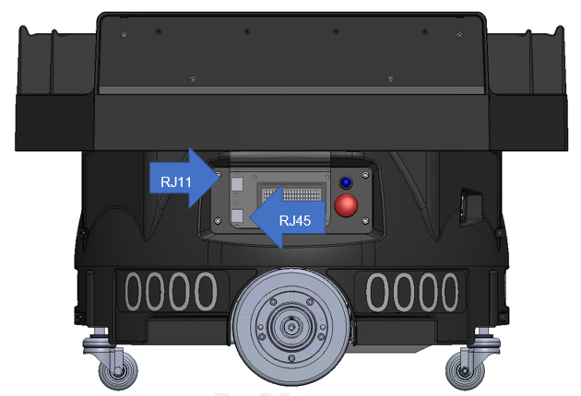
Figure 10 - Starboard Side
Part | Purpose
LCD Screen | Displays messages about errors, state of the FlexBot, FlexBot IP address, and other aspects of the FlexBot. The LCD will display relevant messages during maintenance steps.
Emergency Stop | This red button inhibits any FlexBot motion when pressed. Rotate the button ¼ turn clockwise to release the button. There is an E-Stop button on both sides of the FlexBot. Both operate in the same manner. Only one needs to be engaged to stop motion.
RJ11 Port | This port is used during the manufacturing process and is not active once it leaves the manufacturer.
RJ45 Port | Wired communication port used for direct Ethernet connection to the FlexBot.
Safety Reset Button | This blue button is used to reset the safety system in the FlexBot. There is one on both sides of the FlexBot. The small LED in the center of this button will signify one of the three different states:  - Off- Normal Operation  - Blinking twice per second - The button needs to be pressed to enter a normal operating state  - Blinking once every three seconds - The FlexBot is located outside of the normal operating zone.

Casters
The four casters (PN: 114307), two on the front and two on the rear, provide independent suspension for the FlexBot.
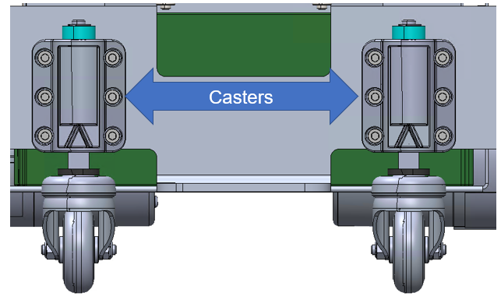
Figure 11 - Casters

PGV (Position Guided Vision)
The PGV (PN: 108171) scans the fiducials. The PGV is a core component to determining the drive path and FlexBot behavior; using information gathered from scanning each fiducial such as angle of attack, and time between fiducials.
The PGV is connected to the APB (application processor board) using a physical cable. The APB processes the information from the PGV and sends the appropriate commands to other components of the FlexBot, such as drive motors.
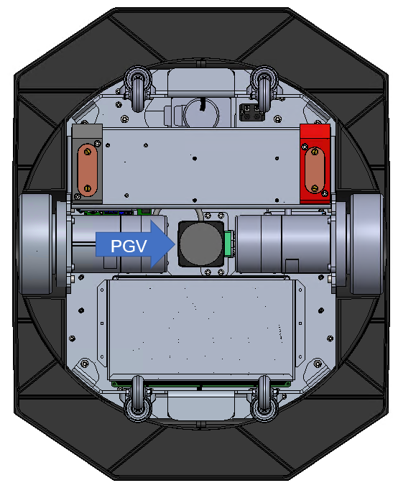
Figure 12 – PGV location

PCBAs and cabling

Motor Control Board (MCB)
- Controls the drive motors
- QTY-2

Application Processor Board (APB)
- Runs most of the logic for the FlexBot and sends control commands to other FlexBot systems. Major components are the SOM (System On Module), IMU (Inertial Measurement Unit)
- QTY-1

Power Distribution Board (PDB)
- Responsible for managing and distributing the power to all the components in the FlexBot
- QTY-1

Siemens Carrier Board (SCB)
- Responsible for all safety controls logic, or the FlexBot safety PLC.
- QTY-1

WIFI Antenna
There are 2 WIFI antennas on the front and rear of the FlexBot that are responsible for the wireless communication between the FlexBot and the rest of the system.
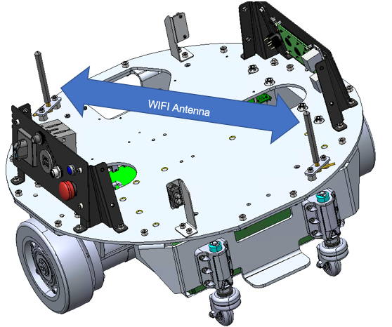
Figure 14 - WIFI antenna locations

Payload Lift/Lower Assembly
The Payload Lift/Lower Assembly (108054) is what lifts containers off and onto the appropriate FlexFeeds and FlexShelves as the containers move through the robotic sortation system. The assembly is normally in the down position. It is only up when engaging or carrying a container. The up position is 100mm (4 in) above the down position.
The assembly uses a scissor lift to raise, lower and support the load using a motor controlled by an MCB.
The Payload Lift/Lower Assembly also connects the Mobile Base to the Rotary Stage, meaning that there are wires routed through this assembly. To avoid internal snags and to keep the motion areas clean, extensive wire and cable management is used on both local and pass-through wiring in and around the assembly.
The figure below illustrates the Payload Lift and Lower Assembly in the raised position without deck rotate assembly installed.
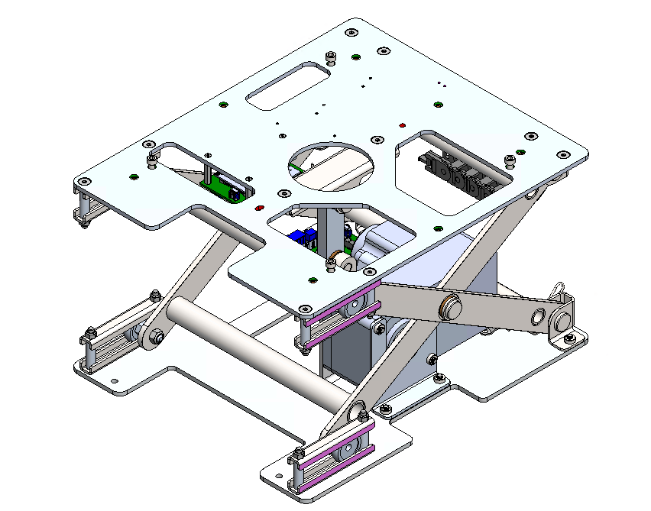
Figure 15 - Payload Lift and Lower Assembly

Scissor Frame
The scissor frame is what supports the load and provides rigidity to the FlexBot while carrying a load. It is made up of two welded frames held together by cotter and clevis pins moving on rollers.
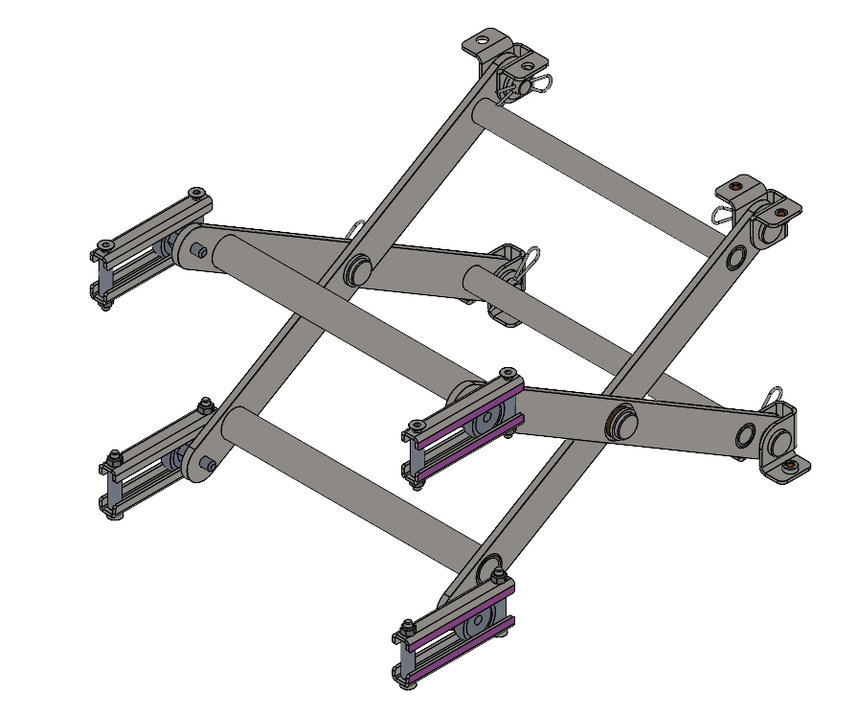
Figure 16 - Welded Scissor frame with rollers and pins

Lift Motor/ Crank Arm/ Reed Switch
The lift motor, crank arm, and reed switch control the lift and lowering of the Payload Lift/Lower assembly.
The motor has a built-in encoder that helps it control its speed and position. The motor also has a gear box incorporated with it from the manufacturer. The gear reduction ratio of this motor is 100:1. It has a recommended torque of 34 N-m (300 lb-in). This motor is well guarded well within the FlexBot. During servicing the FlexBot it is recommended to follow safety procedures to avoid this motor becoming a pinch point.
The reed switch is a homing feature that tells the FlexBot when the deck is in the down position. A reed switch works using magnets, which means it is susceptible to fault when in close contact with other magnets.
The crank arm forms the connection between the motor and the payload.
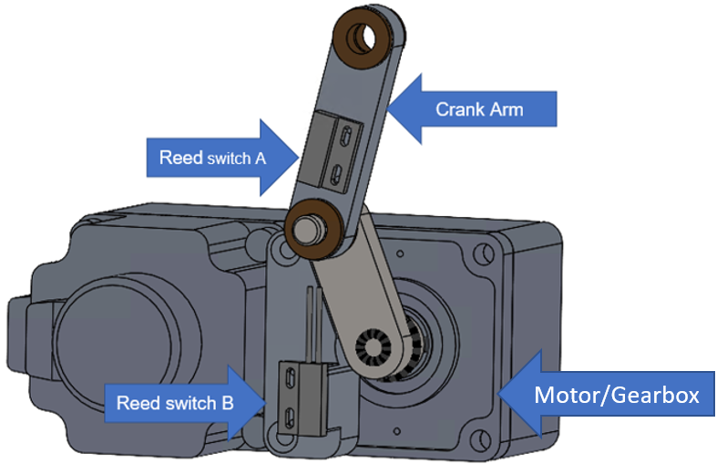
Figure 17 - Motor, Crank Arm, and Reed Switch
Reed switch B
Motor

Motor Control Board (MCB)
There are two MCBs mounted in the Payload Lift/Lower assembly, one for controlling the lift/lower motor and the other for controlling the deck rotate motor. These are also the same MCBs that are used to control the drive motors in the Mobile Base.
While these boards are physically identical, they have unique programming for the distinct functions that they perform. Due to this specialized programming, these MCB boards are not interchangeable.
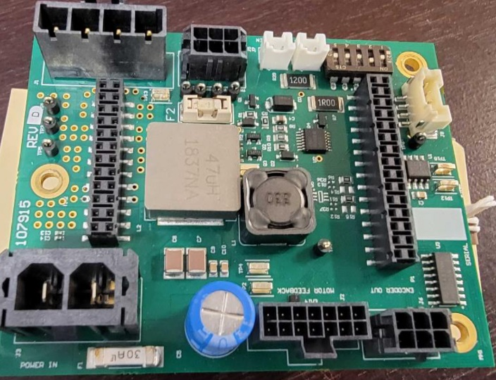
Figure 18 - Motor Control Board (MCB)
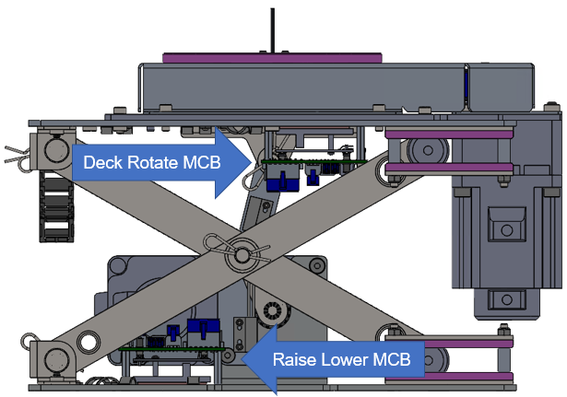
Figure 19 - MCB Locations on lift lower assembly

Wire Routing & Cable Management
Wire routing and cable management is especially important in the Payload Lift/Lower assembly due to its range of motion. If wires and cables are not properly secured they may get caught and break. The cable management features are built in, and all should be used as designed.
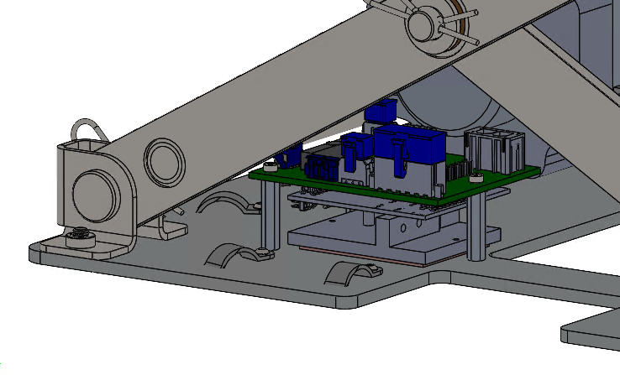
Figure 20 - Cable management locations - View 1
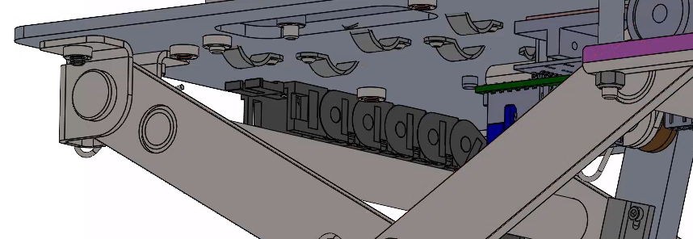
Figure 21 - Cable management locations - View 2

Energy Chain Entrance Wires and Cables
These images show the energy chain entrance. The MCB Rotate Power cable (108174-04), Canbus cable (108180-04), Absolute Encoder cable (109825), Deck Presence Sensor cable (108183), and the STO cable (108187) are the cables routed within the energy chain.
The wires should be bundled together with zip ties and tied down with mechanical clamps at indicated locations to provide adequate clearance from the scissor lift frame. Tie wraps should not be used inside the energy chain track.
Mechanical tie down features, such as clamps, are provided to bundle cables and bind them such that they are clear of the scissor frame and do not move.
Cables must also be mechanically tied down to remain clear of the lift motor’s crank arm, especially the lift motor cables.
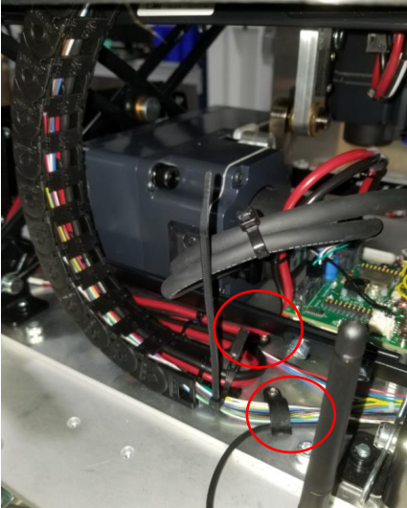
Figure 22 - Energy Chain Location Entrance

Encoder and Slip Ring Wires and Cables
The Encoder and slip ring wires should be tucked out of the way using the wire clips, as shown below. It is important to ensure the cotter pin does not get entangled in these wires. This clevis pin is free to rotate and if wires are not secured properly, they may get caught on the cotter pin during normal operation.
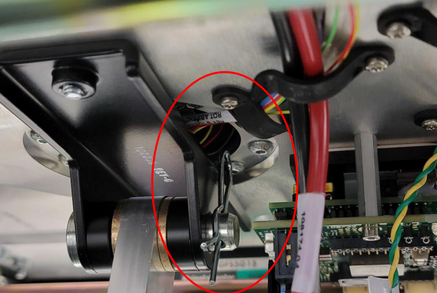
Figure 23 - Encoder and slip ring wires

Rotary Stage
The rotary stage is the assembly that rotates the payload deck. It can rotate infinitely due to design. The primary components are a motor that drives the rotation motion, a Motor Control Board that controls the motor, the drive mechanism that transfers the motion of the motor to the payload deck, a cover for safety, and a slip ring with an absolute encoder that controls the position while providing an electrical connection from the lower part of the FlexBot to the Deck Presence Sensors.
During normal operation, the deck normally orients in line with the shelves, while the mobile base drives and turns in different directions. The only time this is not true is when the FlexBot is discharging its container.
This assembly mounts directly to the top of the Payload Lift/Lower assembly as shown in Figure 24, and then payload deck mounts to the top of the deck rotate assembly.
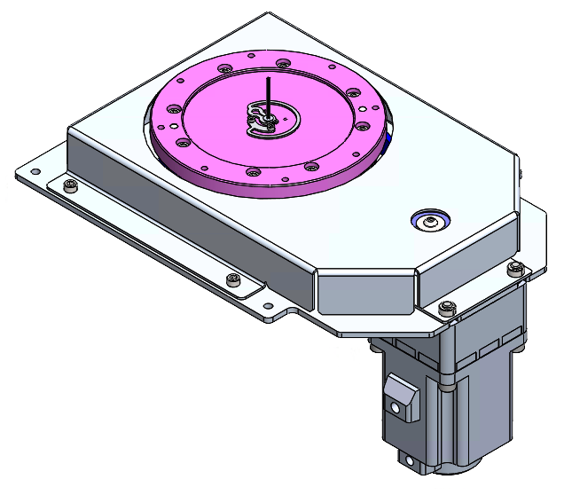
Figure 24 - Deck Rotate Assembly

Deck Rotate Motor
The Deck Rotate Motor drives the rotation of the deck rotate assembly. There is a built-in encoder in the motor that helps control the motion and speed of the motor. A pulley installed on the motor shaft transfers the motion created by the motor to other parts of the system.
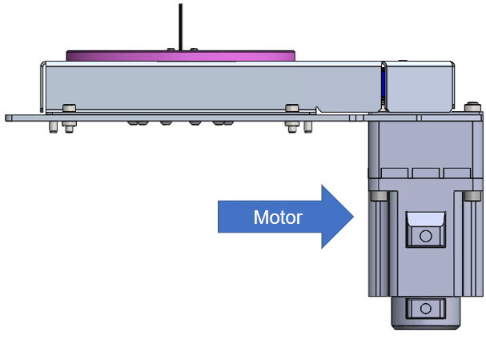
Figure 25 - Deck Rotate Motor

Deck Rotate Motor Control Board (MCB)
The deck rotate MCB is mounted in the Payload Lift/ Lower assembly, seen in Figure 19. This MCB is almost identical to the other MCBs but is programmed to be used specifically for the deck rotate motor. The MCBs are not interchangeable.

Pulley/Belt/Slew Ring
The pulley, belt, and slew ring transfers the motion from the deck rotate motor to the payload deck. The pully and slew ring are geared for a specific gear ratio and uses a specific tooth profile for the belt to ensure correct timing.
When disassembling and reassembling this assembly, there is no specific orientation that the pulley, slew ring and belt must be in. During maintenance, there is a process for re-zeroing this assembly which is done electronically. The pulley is keyed to allow a solid connection to the motor shaft.
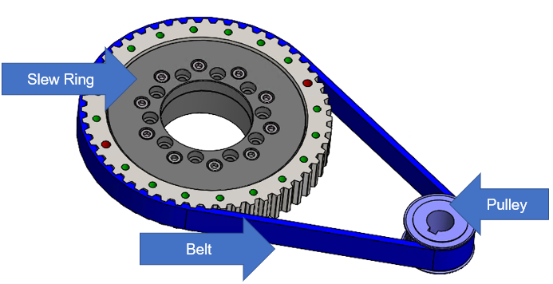
Figure 26 - Pulley, Belt, and Slew Ring

Cover Plate
The cover plate (108028) protects both the FlexBot and a person performing maintenance on the FlexBot. It is a sheet metal cover that is used to shroud the moving parts of the deck rotate assembly.
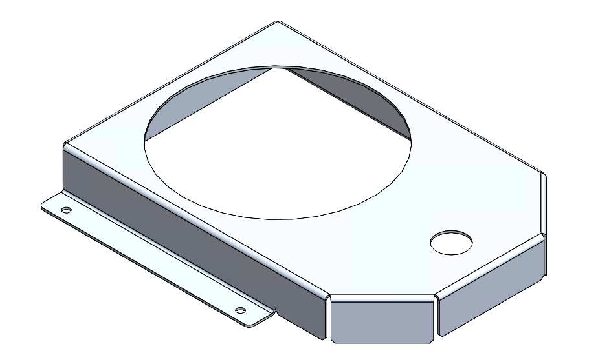
Figure 27 - Cover Plate, Belt Drive

Slip Ring/Absolute Encoder
The slip ring and absolute Encoder (100204) are two separate components built into one assembly. The slip ring transmits electricity from the Mobile Base to the deck presence sensors while allowing for continuous and infinite rotational motion of the deck. The absolute encoder provides the rotational position of the deck to the FlexBot. These two components are assembled together and should be considered a single component.
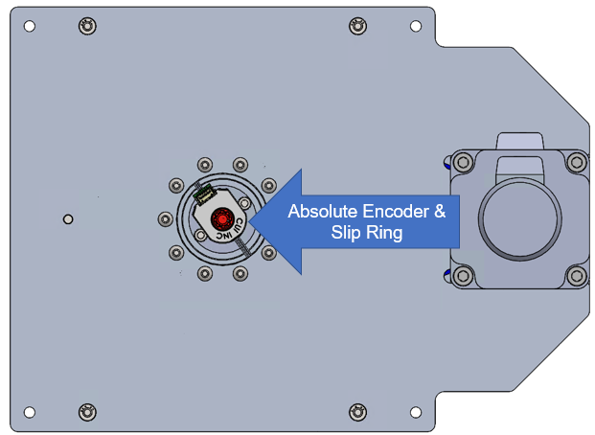
Figure 28 - Slip Ring and Absolute Encoder - View 1
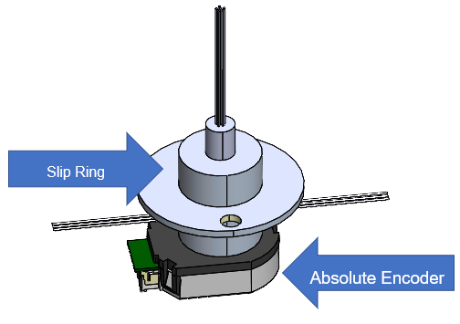
Figure 29 - Slip Ring and Absolute Encoder - View 2

G-Clip
The G-clip (100204) connects the movement of the slew ring to the slip ring shaft. This connection allows the FlexBot to know the true position of the deck. It is made from spring steel and allows for limited eccentricity and compliance during rotation. During removal and install of the G-clip, it is important not to apply too much force and permanently deform the clip.
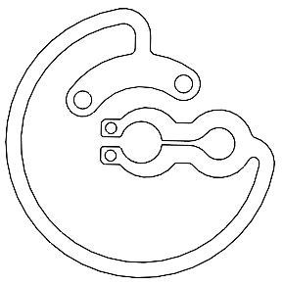
Figure 30 - G-Clip

Payload Deck and Covers

Molded Payload Deck
The molded deck (108817) physically contacts the payload on the FlexBot during handling. It is specially designed to interact with the FlexFeeds and shelves. There are a series of deck presence sensors either side of the deck facing inwards to detect whether there is a container on top or not.
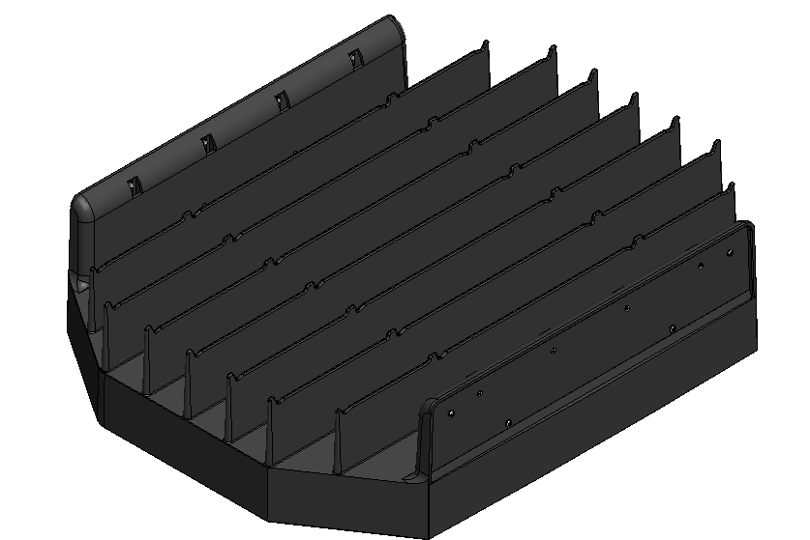
Figure 31 - Molded Deck with Side Covers

Deck Presence Sensors
The Deck Presence sensors tell the FlexBot if there a container on the payload deck or not. They work by generating infrared light beams from transmitters on one side of the deck to receivers on the other side of the deck. Breaking the infrared light beams will signal the FlexBot that there is indeed an object on the deck.
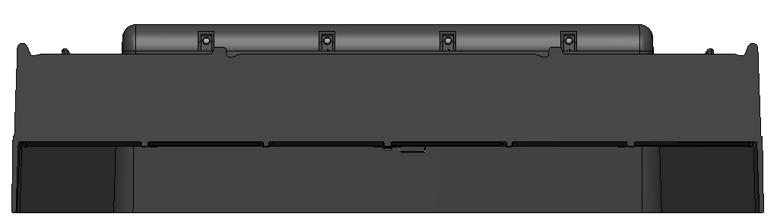
Figure 32 -Deck Presence Locations

Payload Deck Wire Guarding
There are two guards on the underside of the payload deck to protect the deck presence sensors wires.
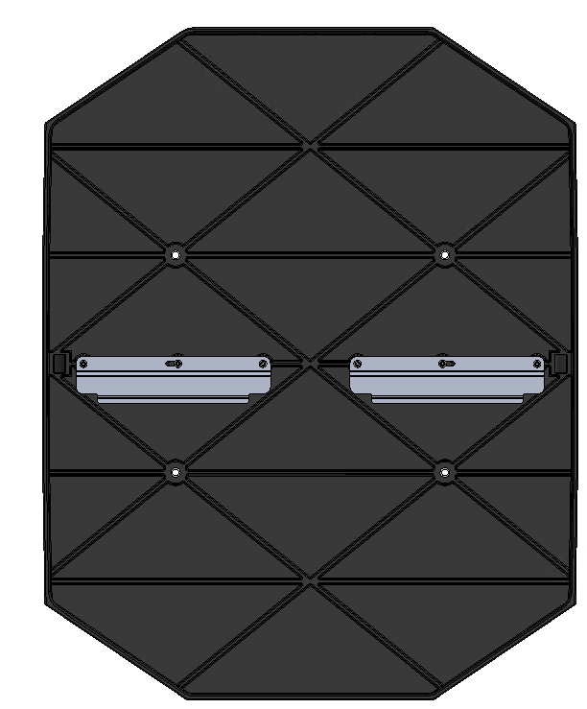
Figure 33 - Molded Deck with wire guards

Housings and Shield
The housings and shields are used to minimize ingress of foreign objects into the FlexBot as well as protecting maintenance personnel. The housings covering the chassis and lower portions of the payload lift/lower assembly are identical parts on the port and starboard side. The upper portion of the payload lift/lower assembly is enclosed using another shield part.
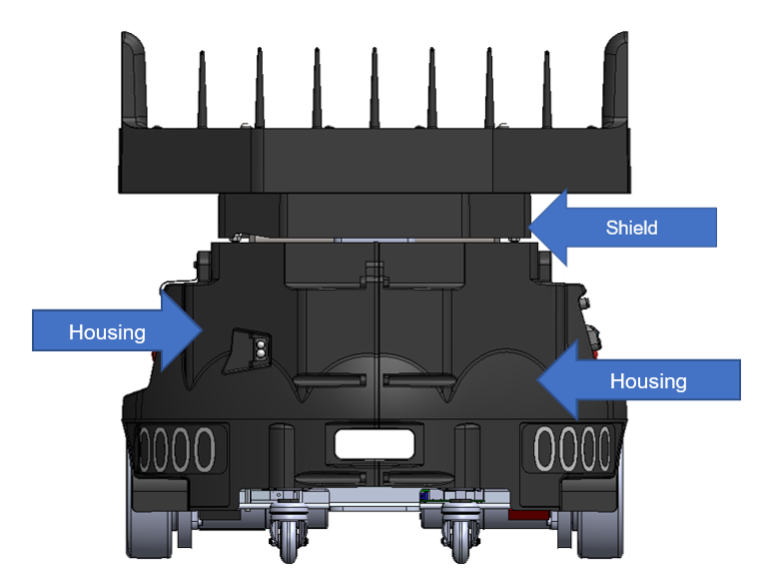
Figure 34 - Housings and Shield

LED Panels
Illuminating in assorted colors the LED Panel on the front and rear of the FlexBot indicates the state of the FlexBot. Below are descriptions of what the LED panel is indicating.
LED Color | Meaning
Green | Normal operation no container
Blue | Normal operation w/ container
Cyan | Charging
Purple | No connection to FlexBot manager
Flashing Yellow | Maintenance Dongle Inserted
Orange | No fiducial seen
Red | Safety stop (global E-Stop/pressing the E-Stop button)
Flashing Red | Safety System is not updating

FlexBot Safety

Safety Features during Operation
The FlexBot 2.0 has a safety system that is designed to have a supervisor roll in movement and location of the FlexBot as it moves on the FlexTile field.
The Safety System uses checks and balances to sense, validate and confirm the FlexBot is moving in an enabled FlexTile field zone.
Conversely, if a FlexBot is in a disabled FlexTile field zone, the supervisor component inhibits the FlexBot movement. There are two components of the system:
1. The FlexBot safety controller.
2. The High-Level Safety Controller.
The two devices communicate with each other validating location and ability to move in a FlexTile field zone. Both the FlexBot safety controller and High-Level Safety Controller use independent checks and balances to sense, validate and confirm the FlexBot’s location and the ability to move in an enabled FlexField zone.
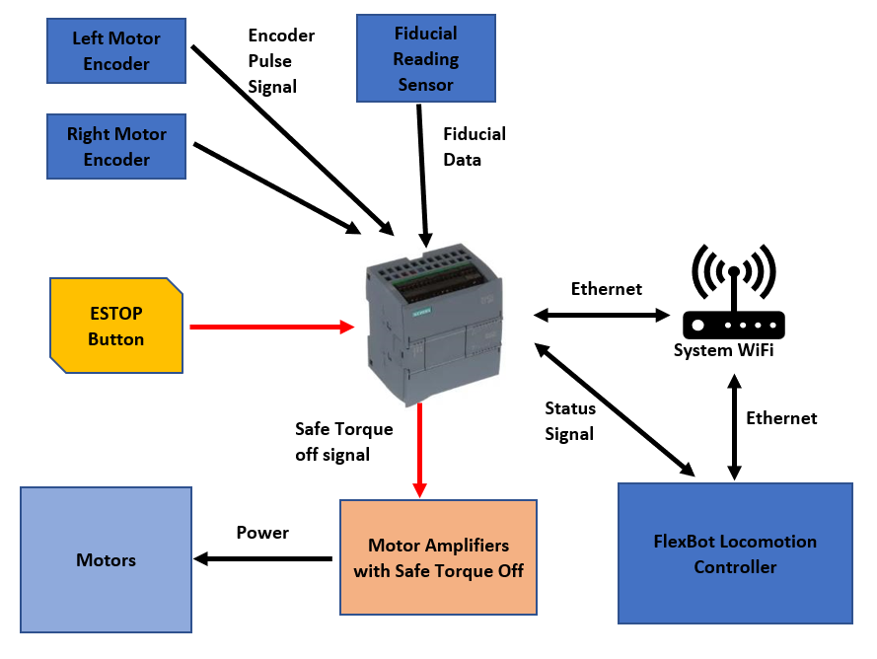
Figure 35 - FlexBot 2.0 Safety System Block Diagram

Safety Controller Communication
The FlexBot Safety Controller and the High-Level Safety Controller exchange information 10 times every second. The High-Level Safety Controller only responds to verified information it receives from the FlexBot Safety Controller. The messages are communicated using a Siemens Profisafe protocol over Wireless Ethernet.
The Wireless Ethernet is an unsecured channel that is not safety rated nor 100% reliable. Safety systems can use such non-reliable communication because the devices at each end of the unsecured channel are safety devices that can make safety decisions in the absence of active communication.
The High-Level Safety Controller activates only a few tiles ahead of the FlexBot while leaving active a few tiles behind the FlexBot. As the FlexBot moves through the field tiles are activated in front of the FlexBot in the intended direction of the bot. If the FlexBot runs out of active tiles before the High-Level Safety controller activates new tiles the bot will stop.
The lack of a sequential response from the High-Level Safety Controller to the FlexBot Safety Controller is an indication of a shutdown condition.
Safety Controller Verification
As mentioned earlier, the FlexBot Safety System uses checks and balances to sense, validate and confirm the FlexBot is moving in an enabled FlexField zone.
The check and balances are outlined in the following individual validations. If any of the validations fail, the FlexBot Safety System informs the FlexBot controller of a pending shutdown process and movement stop.
Direction and distance measurements between fiducials
The FlexBot Safety Controller measures the distance traveled using the two encoder sensors on the two FlexBot locomotion motors.
Each encoder sensors produces two square wave signals that are changed into count and direction pulses that the FlexBot Safety controller keeps track of to measure the distance a FlexBot has moved. To validate that a FlexBot is moving in an expected manner, the calculated distance between scanned fiducials is verified with the expected distance between fiducials.
Correlation between distance travelled and new fiducials
As the FlexBot moves and measures distances, the FlexBot Safety Controller expects to see fiducials at known distances. The opportunities for fiducial data to be received are interpreted as windows of opportunity that open and close depending upon the distance traveled by the FlexBot.
If the FlexBot moves a distance equaling the distance between fiducials (within a degree of tolerance), a window of opportunity to receive a new fiducial opens and a new fiducial is expected. Conversely, if the FlexBot moves a distance less than the expected distance between fiducials, the window of opportunity to receive a new fiducial is closed and a new fiducial is not expected.
Further still, if the FlexBot has not moved from a fiducial, the window of opportunity to receive fiducial stays open expecting the same fiducial and a new fiducial is not expected. Only when scanning a new fiducial in an expected window of opportunity is a safety message with the new fiducial information sent to the Higher-Level Safety PLC to validate the fiducial.
Maximum velocity verification
In addition to The FlexBot Safety Controller measuring the distance traveled, the velocity of the FlexBot locomotion motors is also monitored not to exceed a maximum expected speed. As the controller on the FlexBot commands the locomotion motors to move, it reports the expected velocity to the FlexBot Safety Controller to verify that that locomotion motors are performing as expected. This validation indirectly verifies that the encoders are functioning as expected.
Siemens Profisafe message validity verification
The last validation check that the FlexBot Safety Controller performs is a validation of the Siemens Profisafe communication of the safety messages.
In the event of communication data corruption or loss, the communication values are set to fail safe values causing the FlexBot Safety Controller to perform a shutdown process and movement stop.
High Level Safety Controller Verification
Like the FlexBot Safety System, the High-Level Safety Controller also uses checks and balances to sense, validate and confirm the FlexBot is moving in an enabled FlexTile field zone.
The High-Level Safety Controller uses a separate set of checks and balances expanding validation diversity of the FlexBot Safety System. Those check and balances are outlined below in the following individual validations that are performed every time a safety message is received from the FlexBot Safety System.
Fixed map of fiducials of the FlexTile field
The High-Level Safety Controller has a fixed map of all the fiducials and their respective locations. When the FlexTile field is installed, a map is generated of all the fiducial locations and zones. The High-Level Safety Controller uses this map to validate the location and control the movement of the FlexBots on the FlexTile field.
FlexBots that are in enabled FlexTile zones are allowed to move freely while those FlexBots in disabled FlexTile zones are inhibited from moving.
Correlation of reported fiducials and a fixed map of fiducials
When a FlexBot sends a message about the fiducial seen to the High-Level Safety controller, that fiducial is checked to be on the fixed map of FlexTile field fiducial. Once a fiducial is validated, the FlexTile zone status is checked.
FlexBots that are in enabled FlexTile zones receive a reply from the High-Level Safety controller that the fiducial is validated and FlexTile field zone is enabled. FlexBots that are in disabled FlexTile zones receive a reply from the High-Level Safety controller that the fiducial is validated and FlexTile field zone is disabled.
FlexBot location history
In addition to validating the FlexBot reported fiducials are found on the fixed map, the High-Level Safety Controller also keeps a history of the last fiducial reported by a FlexBot. The last fiducial reported is validated to be adjacent to the current fiducial reported.
The fiducial history validation is to check if the fiducials reported are valid in sequence found in the fixed map as the FlexBot moves from one fiducial to another so the FlexBot cannot just report random fiducials any time.
Correlation of adjacent reported fiducials
The High-Level Safety Controller keeps a history of the last fiducial reported by a FlexBot. The last fiducial reported is validated to be adjacent to the current fiducial reported.
The adjacent fiducial validation checks if the fiducials reported are valid in sequence found in the fixed map as the FlexBot moves from one fiducial to another. This validation is so the FlexBot cannot just report random fiducials any time. As part of the Fiducial validation by the high-level safety system, one of the two fiducials that are adjacent to the currently reported fiducials must be equal to the fiducial last reported, or as in the history of the last fiducial reported. The system only validates two fiducials adjacent to the current reported fiducial thus allowing one fiducial to be missed and allow the current fiducial to be validated

Fiducial Timeout
The FlexBot has the ability to miss a fiducial. There is a timeout of 4 seconds built into the FlexBot that if a fiducial is not seen it will stop driving and the LED will change from it’s current color to orange which means fiducial not sen.
Siemens Profisafe message validity verification
The last validation check that the High-Level Safety Controller performs is Siemens Profisafe communication safety message validation. In the event of communication data corruption or loss, communication values are set to fail safe values. Fail safe values cause the High-Level Safety Controller to send response messages to the FlexBot that the fiducial reported is invalid and the FlexBot must perform a safety stop.
Safety System User Interface
The FlexBot Safety System has a user interface consisting of an illuminated E-Stop and Reset button on the left and right side of the FlexBot. In addition, the maintenance connector is found on the left side of the FlexBot.
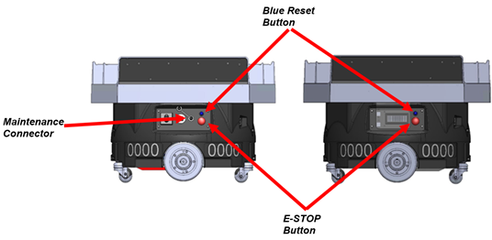
Figure 36 - FlexBot Safety System User Interface

E-Stop Button
The red illuminated E-Stop button is a push Emergency Stop button that disables all the motors in the FlexBot from moving. The E-Stop button is pressed to activate the E-Stop and disable all motors of the FlexBot.
A “turn and pull motion” is required to deactivate the E-Stop. Following an E-Stop activation and deactivation, a reset procedure (see below) is required to re-enable the FlexBot motors.

E-Stop Illumination
The E-Stop button has an illumination feature while the FlexBot is powered on. The E-Stop button is normally not illuminated when E-Stop is not activated, or the E-Stop button has not been pressed.
The illumination on both E-Stop buttons will flash twice per second after the button has been pressed to indicate that an E-Stop button has been pressed on either side of the FlexBot.

Maintenance Connector
The FlexBot Safety System has a maintenance connector. A special maintenance dongle is connected to the maintenance connector putting the FlexBot Safety System into a maintenance mode disabling the fiducial validation.
While in maintenance mode, the FlexBot can be evaluated to ensure proper operations as a part of maintenance tasks. When the maintenance dongle is connected, a reset button (see below) must be pressed when indicated to enable the maintenance mode.
The Reset button must be pressed again, when indicated, when the maintenance dongle is removed to return the FlexBot to normal operation.

Reset Button
The Reset button is a push button to set the FlexBot Safety System into a known operating state. The Reset button needs to be pressed when flashing to acknowledge and authorize the FlexBot Safety System to enter an operating state. This is the case after the FlexBot has recovered from an error or is powered on.

Reset Button Illumination
The Reset button has an illumination feature while the FlexBot is powered on. The button illumination is normally off when the FlexBot does not need the attention from a technician.
The illumination will flash twice per second if the Reset button needs to be pressed by a technician to acknowledge and authorize the FlexBot Safety System to enter an operating state.
The illumination will flash once every three seconds when the FlexBot Safety System is inhibiting all motion on the FlexBot when the FlexBot is in a disabled FlexTile zone. This light pattern is only an indication the FlexBot is in a disabled zone and does not require any action by a maintenance technician.

Maintenance Safety
Before a Robotics Technician (RT) performs maintenance on the FlexBot, and RT should be familiar with these concepts and processes to ensure a safe working environment.

Safely Moving the FlexBot
The FlexBot is a 120-pound piece of equipment needing specials tools and multiple people to move it properly.
The recommended tool for moving the FlexBot while on the floor is the FlexBot Removal Tool (FRT). The FRT has a specially designed fork meant to interface with the casters of the FlexBot. The points of the tool insert under the metal flange of the caster when the handle is pushed down drive wheels of the FlexBot are lifted allowing easy movement of the FlexBot.
This tool should be used for manually moving/rolling the FlexBot on floors such as the FlexField, in the RSS Shop, and in between both areas.
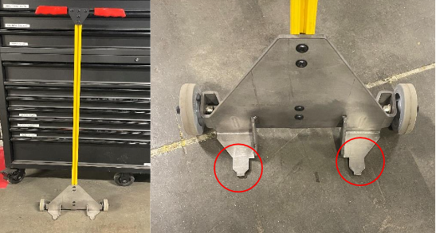
Figure 37 - FlexBot Removal Tool (FRT) highlighting caster lift points
There are two ways for lifting the FlexBot: the FlexBot Lift and the Team Manual Lift. The FlexBot Lift is an electric lift. This lift has custom designed arms that clamps to the FlexBot. The lift is designed to be used for maintenance; the FlexBot must have the housings removed to safely clamp onto the FlexBot. The FlexBot lift can move the FlexBot up, down, and rotate it 360 degrees.
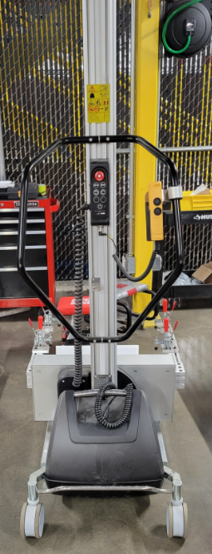
Figure 38 - FlexBot Lift
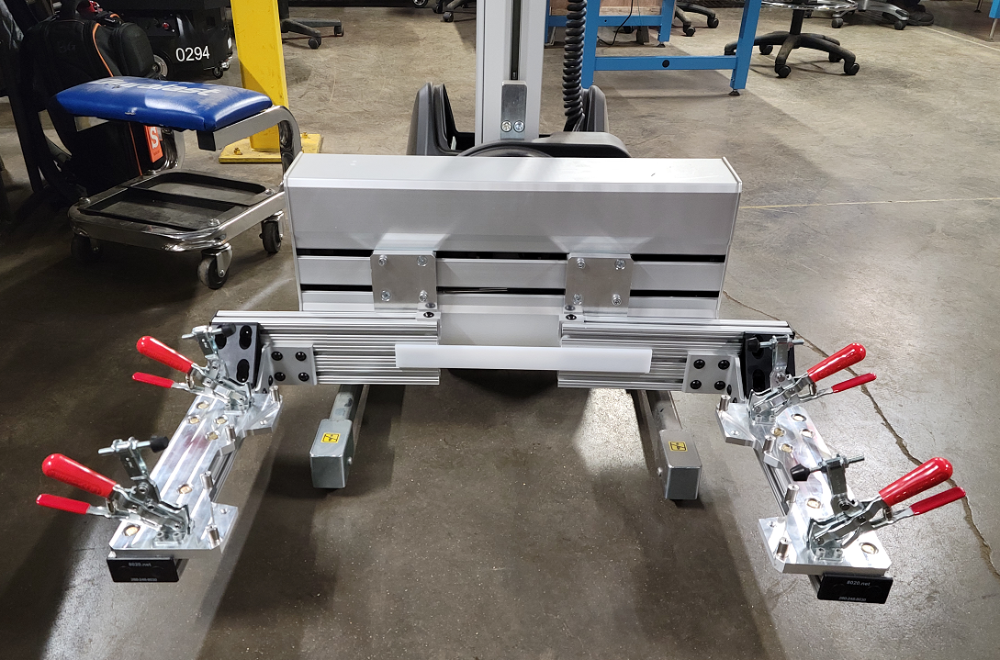
Figure 39 - FlexBot Lift Arms
The Team Manual Lift is a procedure requiring two people. This procedure is designed with the housings of the FlexBot still on. The housings of the FlexBot have hand holds designed into them for lifting it. This procedure is done when lifting the FlexBot onto to bench and onto the maintenance cradle.
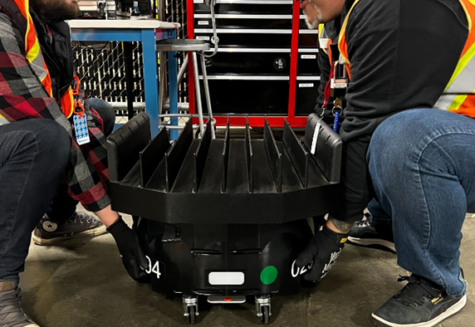
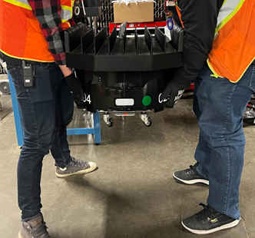
Figure 40 - FlexBot Team Lift

Safely Performing Maintenance on the FlexBot
To safely perform maintenance on the FlexBot there are certain pieces of equipment and power states that you should be familiar with. There are two pieces of equipment recommended for working on the FlexBot: The FlexBot Lift and the FlexBot Maintenance Cradle. The FlexBot Maintenance cradle is designed to be used on a bench top. The FlexBot lift Is another maintenance tool like the cradle, but it allows a technician to easily work on the underside of the FlexBot.
The maintenance cradle elevates the FlexBot slightly off the bench so that the FlexBot can activate certain components freely and safely. The FlexBot should be placed on top of this fixture with the battery tray sitting inside section indicated below in the red box in the picture below. The electronics bay should sit inside the yellow box as shown in the picture below.
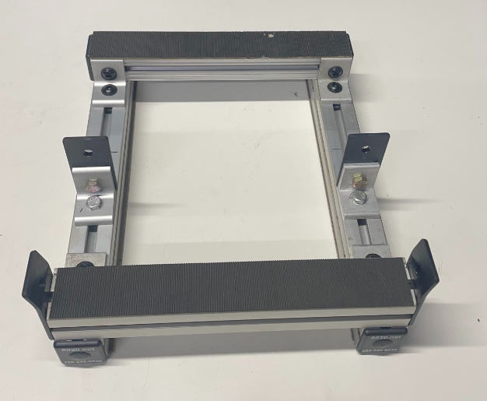
Figure 41 - The FlexBot Cradle Orientation
Once the FlexBot is held safely in one of these two pieces of equipment there are different power states it can be placed into depending on the type of maintenance being performed. The FlexBot can be placed into these various maintenance states via the port and starboard panels of the FlexBot.

Figure 42 - Port Side

Figure 43 - Starboard Side
Maintenance procedures can happen in these maintenance states:
- Powered Off State - The FlexBot is put into this state by turning the power switch to the off position. When the FlexBot is powered off all the components no longer have power.
This powerless state allows for components to be serviced safety while ensuring technician safety as well. The FlexBot Powered OFF maintenance state should be used whenever possible.
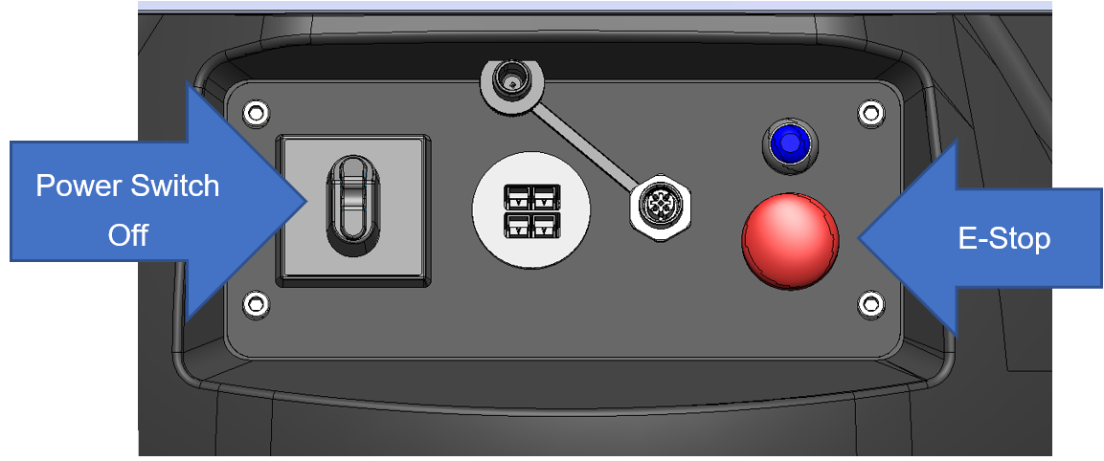
Figure 44 - Port Side Panel with Power Switch in Vertical Off Position
- E-Stop State - When engaged, the E-Stop will inhibit all motors. This includes both drive motors, lift motor, and rotation motor.
The E-Stop should be engaged before powering on the FlexBot and used for maintenance that requires power but no movement.
The E-Stop should be engaged when troubleshooting anything on the FlexBot other than the motors.
- FlexBot in FlexBot Maintenance Cradle - Placing the FlexBot in the Maintenance Cradle creates a safe environment to give the FlexBot motor commands allowing the drive wheels to spin freely with no FlexBot horizontal motion.
Some maintenance processes require giving the FlexBot commands wirelessly through a computer. A maintenance dongle is required to be attached to the FlexBot so the computer can send and receive information to the FlexBot.
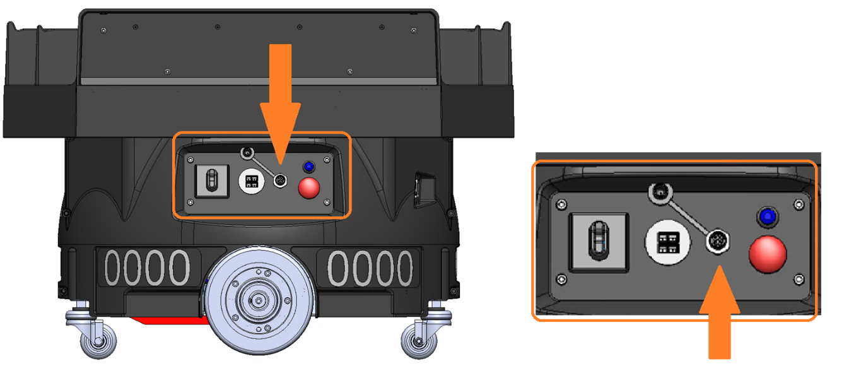
Figure 45 - Maintenance Dongle Receptable Location
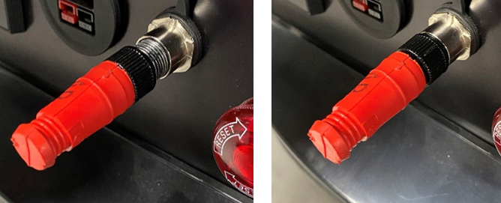
Figure 46 - Before and after Maintenance Dongle attachment
After performing maintenance on the FlexBot, depending on the maintenance, a driving test is usually performed to ensure proper function of the FlexBot. The drive test is performed on the FlexField. Before running the test, the FlexBot should be placed on the field with barriers around it to stop it if there is a malfunction. The maintenance dongle is also used in this process.

FlexBot Commissioning
When a FlexBot is received into a production environment from the manufacturer, a warehouse, or back from repair, it must be commissioned. The commissioning process is a step-by-step procedure for making sure that the FlexBot operates as it is supposed to.
This process makes sure that nothing happened to the FlexBot during storage or shipping. In the Index of Maintenance Procedures, all commissioning procedures are identified.

Unboxing
The FlexBot is shipped in a reusable package. These packages should not be disposed of and should be kept in case the FlexBot needs to be shipped off site. During the unboxing process it is important to track serial numbers and license plate numbers for internal record keeping.

General Functionality Testing
The general functionality testing puts the FlexBot through a battery of tests to make sure that all features of the FlexBot work properly. This test is broken into two parts, a static function test and a driving function test.

FlexBot Static Function Test
This is the first test to make sure all components function properly. This evaluates the motors, the sensors, and makes sure all the wiring properly routed and connected. This test is performed on a maintenance cradle to ensure safe working conditions.
Use of the Maintenance Cradle allow testing of the FlexBot; keeping the wheels elevated to prevent movement across the floor or table. These tests can spin the drive wheels, raise, lower, and rotate the payload deck, and ensure all the associated sensors work while performing all these operations.

FlexBot Drive Test
After the FlexBot passes the static function test it is considered safe to drive, but not safe to put into production. After performing and passing the Drive test it will be safe to put into production. The Drive test is a basic test putting the FlexBot through a basic list of normal operations it would see in production.
In this test the FlexBot will perform driving, rotating, shelving, picking up containers, dropping off containers, and other functions that it would see in a production environment. This test should be performed in a safe environment with barriers to keep people safe.

FlexBot Preventive Maintenance
The FlexBot is a device that requires normal maintenance and inspections. It is recommended that these procedures are performed every 150 miles to ensure proper function. All preventative procedures are identified in the Maintenance Procedures Index.

150 Mile Inspection
The 150 Mile inspection is performed to make sure major components in the FlexBot are functioning properly and not showing any signs of major wear. The procedures and inspection points for the 150 Mile Inspection include:
- Deck Inspection and Cleaning
- Housing and License Plate Inspection
- Caster Inspection and Cleaning
- Port and Starboard Panel Inspection
- Cable Management Inspection
- PGV Inspection and Cleaning
- Deck Presence Sensor Inspection and Cleaning
- Drive Wheel Inspection and Cleaning
These are the major areas of wear in the FlexBot. If wear is noted during these inspections service or maintenance is recommended correcting noted discrepancies.
Other components of the FlexBot may also show wear that are not part of these inspections. If other aspects show excessive wear or damage they should also be serviced at this time.

FB Maintenance Tool
The FB Maintenance Tool is a custom piece of software created by Berkshire Grey. This software is loaded on a RT laptop and is used by Robotics Technicians (RTs) to control a FlexBot for diagnostic, maintenance, and repair purposes when the FlexBot is off the FlexField.
Some commands in the FB Maintenance Tool are also used during FlexBot commissioning to verify the FlexBot is ready for service. The FB Maintenance Tool can command and control various key systems on the FlexBot once connected to a FlexBot under evaluation.
 | When using the FB Maintenance tool, the maintenance dongle must be installed on the FlexBot. The FlexBot must be secured in the Maintenance Cradle for all tests except the Driving test.  Do not use the FB Maintenance tool while the FlexBot is under full control of the orchestrator.  For more information, see:  - BG FlexBot 1010-01 FlexBot - FB Maintenance Tool on the RT Laptop  - BG FlexBot 1002-01-Maintenance Dongle Use

Files Needed on the RT Laptop
Before the FB Maintenance Tool can be used, these things must be true:
- The RT laptop is on the same Wi-Fi network as the FlexBot.
- The FlexBot IP address is known.
- These additional files are added to the RT laptop within the location of the tool files on the computer before the FB Maintenance Tool software is started:
  - bot file - This file controls various parameters of the FlexBot’s operations when using FB Maintenance tool.
  - map file - This file is a map of the fiducial location on the test field that certain tests will be executed on.
  - goal file - This file is the sequence of action that the FlexBot will perform for the driving test option of FB Maintenance Tool
Without these three files in place, FB Maintenance tool gives an error during the tool startup process.
Notice | The map and goal files must be presented on the system even when a drive test is not planned or used.
Once FB Maintenance tool is connected, it will download the relevant files onto the FlexBot and the terminal program on the computer will display a list of available commands. These commands are described in detail in the BG FlexBot 1010-01 FlexBot - FB Maintenance Tool on the RT Laptop document.
The FB Maintenance tool commands can be categorized into a few general groups:
- Individual drive and motion tests - Used to operate the various motors at specified speed and toggle motor brakes
- Sensor and readout tests - Used to test PGV, IMU, BMS, deck presence sensor, and the LED panel
- Comprehensive system tests such as the validation test and driving test
- Retrieve FlexBot logs such as telemetry, fb-robot stdout
- Deck encoder calibration - Note: This is the only sensor calibration available from FB Maintenance Tool
- Power off FlexBot and exit the program
Some individual system command and tests, such as the motor drive tests, will require user input or interaction such as specifying drive speed or LED color choices. These tests will often have limits to the range of inputs available to the user.
Other commands, such as for the PGV and IMU, will only display a reading or the result.
Commands like toggling the motor breaks will have no displayed output on the RT laptop.
Motor drive tests and sensor tests will remain active until the user exits out of the command using the appropriate command.

Comprehensive Tests
The two comprehensive system tests in FB Maintenance are Validation test and Driving test.
The Validation test is a pre-programmed set of tests of the FlexBot onboard systems. It covers most, but not all, of the individual drive and motion test and sensor and readout tests.
The user input required for the Validation test is for the RT to verify whether the FlexBot successfully performed an action before moving onto the test action. All other characteristics are pre-set.
The Driving test is the only FB Maintenance tool test that requires the FlexBot to be position in a FlexField with fiducials.
Once entered, the Drive test will direct the FlexBot to follow the sequence of actions in the goal file loaded when FB Maintenance tool executed.
Upon the completion of the Drive test, FB Maintenance tool will automatically write the fb-robot stdout log file to the computer. The fb-robot stout log file can be found in the folder where the FB Maintenance tool files on the computer is kept. This file contains all relevant outputs and readouts from the FlexBot during the Drive test and may be used to help diagnose any issues.
Once all operations and testing are complete, the user can soft power off the FlexBot by using the Power off and exit command. This will set all FlexBot motor drive brakes and close any active connections the FlexBot has with any other systems as well as exit FB Maintenance tool. It’s important to note that this is not a safe power off state. All of the components still have electricity slowing to them.
However, the FlexBot is still partially on and drawing power. To fully power off the FlexBot, the user must physically turn the onboard power switch to the off (vertical) position. If the user wishes to reconnect to the FlexBot after the power off and exit command has been entered, the FlexBot must be physically power cycled.

FlexBot Maintenance Procedures Index
Description | Subsystem | PM | CM | SAFETY | Commissioning | Document Number
FlexBot Unboxing Procedure | FlexBot |  |  |  | ✓ | BG FlexBot 1001-01 FlexBot Unboxing Procedure
Maintenance Dongle Usage | FlexBot | ✓ | ✓ | ✓ | ✓ | BG FlexBot 1002-01-Maintenance Dongle Use
Belt Tension Diagnosis | Rotary Stage | ✓ | ✓ |  |  | BG FlexBot 1004-01 Deck Belt - Tension Inspection
Slip Ring and G-Clip Check | Rotary Stage |  | ✓ |  |  | BG FlexBot 1007-01 Slip Ring & G-Clip - Check
Remove and Replace APB | Drive Base |  | ✓ |  |  | BG FlexBot 1009-01 APB - Remove and Replace
Reset Button Replacement | Drive Base |  | ✓ |  |  | BG FlexBot 1011-01 Reset Button Remove and Replace
Belt Replacement | Rotary Stage |  | ✓ |  |  | BG FlexBot 1013-01 Belt - Remove and Replace
Bot Safety E-Stop Replacement | Drive Base |  | ✓ |  |  | BG FlexBot 1014-01 Safety E-Stop - Remove and Replace
Cable Management Inspection | Drive Base | ✓ | ✓ |  |  | BG FlexBot 1015-01- Cable Management Inspection
Can Cable Replacement | Drive Base |  | ✓ |  |  | BG FlexBot 1016-01 CAN Cable - Remove and Replace
Caster Plate Replacement | Drive Base |  | ✓ |  |  | BG FlexBot 1018-01 Caster Plate - Remove and Replace
Deck Inspection and Cleaning | Payload Deck | ✓ | ✓ |  |  | BG FlexBot 1021-01 Deck Inspection and Cleaning
Drive MCB Replacement | Drive Base |  | ✓ |  |  | BG FlexBot 1025-01 Drive MCB Remove and Replace
Drive Test | FlexBot | ✓ | ✓ |  | ✓ | BG FlexBot 1026-01 Drive Test

Description | Subsystem | PM | CM | SAFETY | Commissioning | Document Number
FlexBot Packing Procedure | FlexBot |  | ✓ |  |  | BG FlexBot 1030 -01 FlexBot - Return to Manufacturer
Full Commission Process | FlexBot |  |  |  | ✓ | BG FlexBot 1032 -01 FlexBot - Full Commissioning
General Function Test | FlexBot | ✓ | ✓ |  | ✓ | BG FlexBot 1033 -01 General Function Test
LCD Replacement | Drive Base |  | ✓ |  |  | BG FlexBot 1034 -01 LCD - Remove and Replace
License Plate Replacement on Skin | FlexBot |  | ✓ |  |  | BG FlexBot 1035 -01 - License Plate Remove and Replace
Lift MCB Replacement | Lift/Lower |  | ✓ |  |  | BG FlexBot 1036 -01 Lift MCB - Remove and Replace
Lift Sensor Replacement | Lift/Lower |  | ✓ |  |  | BG FlexBot 1037 -01 Lift Sensor - Remove and Replace
Network Antenna Replacement | Drive Base |  | ✓ |  |  | BG FlexBot 1038 -01 Network Antenna - Remove and Replace
PDB Replacement | Drive Base |  | ✓ |  |  | BG FlexBot 1039 -01 PDB - Remove and Replace
PGV Inspection and Cleaning | Drive Base | ✓ | ✓ |  |  | BG FlexBot 1041 -01 PGV - Cleaning
PGV Replacement | Drive Base |  | ✓ |  |  | BG FlexBot 1042 -01 PGV - Remove and Replace
Plc Replacement | Drive Base |  | ✓ |  |  | BG FlexBot 1043 -01 PLC - Remove and Replace
Deck Presence Sensor Inspection and Cleaning | Payload Deck | ✓ | ✓ |  |  | BG FlexBot 1045 -01 Deck Presence Sensors Inspect and Clean

Description | Subsystem | PM | CM | SAFETY | Commissioning | Document Number
Remove and Replace Drive Motor | Drive Base |  | ✓ |  |  | BG FlexBot 1046 -01 Drive Motor - Remove and Replace
Remove and Replace Lift Motor | Lift/Lower |  | ✓ |  |  | BG FlexBot 1047 -01 Lift Motor - Remove and Replace
Remove and Replace Lift Motor Linkage | Lift/Lower |  | ✓ |  |  | BG FlexBot 1048 -01 Lift Motor Linkage - Remove and Replace
Remove and Replace Rotary Motor | Rotary Stage |  | ✓ |  |  | BG FlexBot 1049 -01 Rotor Motor - Remove and Replace
Remove and Replace Slew Ring Assembly (Rotary Motor Assembly.) | Rotary Stage |  | ✓ |  |  | BG FlexBot 1051-01 - Rotary Stage Assembly Remove and Replace
Shield Removal and Replacement | Rotary Stage |  | ✓ |  |  | BG FlexBot 1056 -01 Shield - Remove and Replace
Terminal Block Replacement | Drive Base |  | ✓ |  |  | BG FlexBot 1059 -01 - Terminal Block and Power Switch Remove and Replace
LED Replacement | Drive Base |  | ✓ |  |  | BG FlexBot 1062 -01 LED - Remove and Replace
Charge Battery | Battery | ✓ | ✓ |  | ✓ | BG FlexBot 1063 -01 Battery - Charging Procedure
Drive Wheel Shaft and Bearing Face Cleaning | Drive Base | ✓ |  |  |  | BG FlexBot 1064 -01 Drive Wheel Cleaning and Inspection
Caster Inspection and Cleaning | Drive Base | ✓ | ✓ |  |  | BG FlexBot 1066 -01 - Caster Inspection and Cleaning
150 Mile FlexBot Inspection | FlexBot | ✓ |  |  |  | BG FlexBot 1076-01- FlexBot 150 Mile Inspection
Battery Change Procedure | Battery |  | ✓ |  |  | BG FlexBot 1077-01 Battery Change

Description | Subsystem | PM | CM | SAFETY | Commissioning | Document Number
Deck Presence Sensor Replacement | Payload Deck |  | ✓ |  |  | BG FlexBot 1078-01- Deck Presence Sensor Replacement
How To Access Scissor Lift (Payload Deck Raise) | Lift/Lower | ✓ | ✓ |  | ✓ | BG FlexBot 1079 -01 - Payload Deck Raise procedure
Maintenance States | FlexBot |  |  | ✓ |  | BG FlexBot 1080 -01 - FlexBot Maintenance States
How To Use FRT | FlexBot |  |  | ✓ |  | BG FlexBot 1081-01 - FlexBot Removal Tool Use Guide
FlexBot Maintenance Cradle | FlexBot |  |  |  |  | BG FlexBot 1082-01 - FlexBot Maintenance Cradle Use Guide
How To Team Lift FlexBot Safely | FlexBot |  |  | ✓ |  | BG FlexBot 1083-01 - FlexBot Manual Team Lift
How To Use VRC Lift Safely | FlexBot |  |  | ✓ |  | BG FlexBot 1084-01 - Vertical Reciprocating Conveyor Usage
Deck Replacement | Payload Deck |  | ✓ |  |  | BG FlexBot 1086-01 - Payload Deck Replacement
Check Panel Connections | Drive Base | ✓ | ✓ |  |  | BG FlexBot 1087-01 - Panel Connections Inspection
ESD Procedure | FlexBot |  |  | ✓ |  | BG FlexBot 1088-01 - Electro-Static Discharge Setup, Checks, and Use
Safe Battery Handling | Battery |  |  | ✓ |  | BG FlexBot 1089-01 - Overview of Safe Battery Handling
Printing License Plate Procedure | FlexBot |  | ✓ |  |  | BG FlexBot 1090-01 -License Plate -Printing
Inspect Housing and License Plate | Payload Deck | ✓ | ✓ |  |  | BG FlexBot 1091-01 - FlexBot Housing Inspection
FlexBot Belt Tensioning | FlexBot |  | ✓ |  |  | BG FlexBot 1092-01 - Belt Tensioning
How To Inspect Scissor Lift | Lift/Lower | ✓ | ✓ |  |  | BG FlexBot 1093-01 - Scissor Lift Inspection
Scissor Lift Roller Channel Inspection | Lift/Lower | ✓ | ✓ |  |  | BG FlexBot 1094-01 - Scissor Lift Roller Channel Inspection
Lifter Arm Mount Wear Inspection | Lift/Lower | ✓ | ✓ |  |  | BG FlexBot 1095-01 - Lifter Arm Mount Wear Inspection
FlexBot Battery Revision and Serial Number Check | FlexBot | ✓ | ✓ |  | ✓ | BG FlexBot 1097-01 - Battery Revision Check
Drive Motor Troubleshooting Process | Drive Base |  | ✓ |  |  | BG FlexBot 1100-01 - Drive Motor Trouble Shooting Process
Rotate MCB Replacement | Rotary Stage |  | ✓ |  |  | BG FlexBot 1101-01 - Rotate MCB Replacement
Replace G-Clip | Payload Deck |  | ✓ |  |  | BG FlexBot 1102-01 - Replace G-Clip
Adding FlexBot to The FlexField | FlexBot |  |  |  |  | BG FlexField 3006-01-FlexBot Addition to FlexField
Removing FlexBot from The FlexField | FlexBot |  |  | ✓ |  | BG FlexField 3007-01-FlexBot Removal from FlexField
LabelTac Printer Set Up | FlexBot |  | ✓ |  |  | BG FlexField 3019-01-Printer Setup for Fiducials and License Plates

